AKSIPS GROUP OF SMART SCHOOLS
SYLLABUS BIFURCATION – TERM WISE
CLASS – IX
SESSION -2026 -27

ENGLISH (LANGUAGE & LITERATURE) (184)
TERM I & II
READING SKILLS
- Questions based on the following kinds of unseen passages to assess inference, evaluation, vocabulary, analysis and interpretation:
- Factual/ Literary Passage (400 – 450 words)
- Case Based Passage (with verbal inputs) – 200 -250 words)
TERM I
WRITING SKILLS:
- Notice Writing, Creating a Poster (Word Limit – Up to 50 words)
- Writing a Letter to the Editor, Formal E-mail on a given issue for presenting views and suggestions (Word Limit – 120–150 words)
- Writing a Speech, Magazine Article based on visual or verbal cues (Word Limit – 120–150 words)
- Narrative Essay (Word Limit – 150–180 words)
GRAMMAR
- Determiners, Sequence of Tenses, Modal Auxiliaries, Subject – Verb Concord, Reported Speech (Statements/Questions/Commands and Requests),
Conditional Clause-Type 1, Clauses- Noun Clause, Relative Clause
- Integrated Grammar Exercises (Paragraph Completion, Sentence Rearrangement, Sentence Transformation))
LITERATURE
KAVERI
Prose
1. How I Taught My Grandmother to Read
2. The Pot Maker
3. Winds of Change
4. Vitamin-M
Poems
- Bharat, Our Land
- Gifts of Grace: Honouring Our Vocations
- Canvas of Soil
- I Cannot Remember My Mother

TERM II
READING SKILLS
- Questions based on the following kinds of unseen passages to assess inference, evaluation, vocabulary, analysis and interpretation:
- Factual/ Literary Passage (400 – 450 words)
- Case Based Passage (with verbal inputs) – 200 -250 words)

WRITING SKILLS:
- Notice writing, Informal Invitation, Creating a Poster (Word Limit – Up to 50 words)
- Writing a Letter to the Editor, Formal E-mail on a given issue for presenting views and suggestions (Word Limit – 120–150 words)
- Writing a Speech, Factual Description, Magazine Article based on visual or verbal cues (Word Limit – 120–150 words)
- Narrative Essay (Word Limit – 150–180 words), Descriptive Essay
- All topics covered in Term I.
GRAMMAR
- All topics covered in Term I
- Integrated Grammar Exercises ((Paragraph Completion, Sentence Rearrangement, Sentence Transformation))

LITERATURE:
KAVERI
Prose
5. The World of Limitless Possibilities
6. Twin Melodies
7. Carrier of Words
8. Follow That Dream
Poems
- Nine Gold Medals
- A Friend Found in Music
- Words
- Believe in Yourself
Assessment of Listening and Speaking Skills will be for 5 marks.

MATHEMATICS (041)
TERM I
Ch-1: Orienting Yourself: The Use of Coordinates
Ch-2: Introduction to Linear Polynomials
Ch-3: The World of Numbers
Ch-4: Exploring Algebraic Identities
Ch-5: I'm Up and Down, and Round and Round
Ch-6: Measuring Space: Perimeter and Area
Ch-7: The Mathematics of Maybe: Introduction to Probability
Ch-8: Predicting what comes next? Exploring Sequences and Progression
TERM II
Book is yet to come

SCIENCE (086)
TERM I
Ch- 1 Exploration: Entering the World Of Secondary Science
Ch- 2 Cell: The Building Block of Life
Ch- 3 Tissues in Action
Ch- 4 Describing Motion Around Us
Ch- 5 Exploring Mixtures and their Separation
Ch- 6 How Forces Affect Motion
Ch-8 Journey Inside the Atom
TERM II
Ch- 7 Work, Energy and Simple Machines
Ch- 9 Atomic Foundations of Matter
Ch- 10 Sound Waves: Characteristics and Applications
Ch-11 Reproduction: How Life Continues
Ch- 12 Patterns in Life: Diversity and Classification
Ch-13 Earth as a System: Energy, Matter and Life
SOCIAL SCIENCE (087)
Term 1
1. Understanding social science
2. ⁠Shaping of the Earth’s Surface
3. ⁠Atmosphere and Climate
4. ⁠Early Humans and Beginning of Civilisation
5. ⁠States and Society up to 1000 CE
6. ⁠Democracy
7. ⁠Elections
8. ⁠Building Blocks in Economics
9. ⁠The Price Puzzle: What derives the Market
Term 2
1. Oceans and Life
2. ⁠Life on Earth
3. ⁠Building a Resilient India (1000- 1700 CE)
4. ⁠India and the World-1 (1900 BCE- 1200 CE)
5. ⁠Authority
6. ⁠From Ideas to Startups
7. ⁠Smart Ways to Manage your Finances

हिंदी ब (085)
वार्षिक पाठ्यक्रम Term-I
पाठ्य पुस्तक- गंगा
गद्य भाग
पाठ:- दो बैलों की कथा
पाठ :- क्या लिखूं?
पाठ :- संवादहीन
पाठ :- ऐसी भी बातें होती हैं
पद्य भाग*
पाठ :- रैदास के पद
पाठ :-राम, परशुराम, लक्ष्मण संवाद
पाठ :-भारति, जय, विजय करें!
व्याकरण भाग : व्याकरण के सभी विषय जोड़े जाएँगे व रचनात्मक लेखन के भी सभी विषय करवाए जाएँगे
शब्द भंडार- समानार्थी शब्द, मुहावरे।
शब्द निर्माण-उपसर्ग, प्रत्यय
विराम चिह्न,संज्ञा ,सर्वनाम,निपात
रचनात्मक लेखन :- अनुच्छेद, अनौपचारिक पत्र, संवाद व चित्र वर्णन
अपठित बोध :-अपठित गद्यांश
Term-II
पाठ्य पुस्तक- गंगा
गद्य भाग:-
पाठ :- आखिरी चट्टान तक
पाठ:- रीड की हड्डी
पाठ- मैं और मेरा देश
पद्य भाग:-
पाठ :-झांसी की रानी
पाठ :- घर की याद
व्याकरण भाग :-
व्याकरण :- व्याकरण व रचनात्मक लेखन की पुनरावृत्ति होगी
रचनात्मक लेखन :- अनुच्छेद, अनौपचारिक पत्र, संवाद लेखन, चित्र वर्णन
अपठित बोध :- अपठित गद्यांश

PUNJABI (004)
Term – I

ਸਾਹਿਤ ਮਾਲਾ
ਕਾਵਿਰਚਨਾਵਾਂ- ਸਮਾਂ, ਵਿਸਾਖੀ ਦਾ ਮੇਲਾ
ਵਾਰਤਕ - ਵਹਿਮੀ ਤਾਇਆ, ਮੁੜ ਵੇਖਿਆ ਪਿੰਡ
ਵੰਨਗੀ - ਕਹਾਣੀ: ਜਨਮਦਿਨ
ਇਕਾਂਗੀ : ਮੌਨਧਾਰੀ
ਵਿਆਕਰਨ : ਵਿਰੋਧੀ ਸ਼ਬਦ, ਲਿੰਗ ਬਦਲੋ, ਸ਼ਬਦ ਸ਼ੁੱਧੀ, ਵਿਸਮਿਕ, ਕਿਰਿਆ , ਲੇਖ ਰਚਨਾ, ਪੱਤਰ (ਨਿੱਜੀ ਅਤੇ ਬਿਨੈ),
ਚਿੱਤਰ ਵਰਨਣ, ਮੁਹਾਵਰੇ ( ੳ ਤੋਂ ੲ ) ਅਣਡਿੱਠਾ ਪੈਰਾ, ਅਣਡਿੱਠੀ ਕਾਵਿ-ਟੁਕੜੀ
Term - II

ਸਾਹਿਤ ਮਾਲਾ
ਕਾਵਿ ਰਚਨਾਵਾਂ- ਮੈਂ ਪੰਜਾਬੀ, ਨਵੀਂ ਪੁਰਾਣੀ ਤਹਿਜੀਬ, ਮਾਤਾ ਗੁਜਰੀ ਜੀ
ਵਾਰਤਕ- ਖੁਸ਼ੀਆਂ ਆਪੇ ਨਹੀਂ ਆਉਂਦੀਆਂ, ਬੇਬੇ ਜੀ
ਵੰਨਗੀ - ਕਹਾਣੀ: ਸਾਂਝੀ ਕੰਧ, ਬੱਸ ਕੰਡਕਟਰ
ਇਕਾਂਗੀ- ਸਿਰਜਣਾ
ਵਿਆਕਰਨ : ਵਿਰੋਧੀ ਸ਼ਬਦ, ਲਿੰਗ ਬਦਲੋ, ਸ਼ਬਦ ਸ਼ੁੱਧੀ, ਵਿਸਮਿਕ, ਕਿਰਿਆ,ਲੇਖ ਰਚਨਾ, ਪੱਤਰ (ਨਿੱਜੀ ਅਤੇ ਬਿਨੈ),
ਚਿੱਤਰ ਵਰਨਣ, ਮੁਹਾਵਰੇ ( ਸ ਤੋਂ ਹ ) ਅਣਡਿੱਠਾ ਪੈਰਾ, ਅਣਡਿੱਠੀ ਕਾਵਿ-ਟੁਕੜੀ

INFORMATION TECHNOLOGY (402)

TERM I
PART-A Employability Skills
Unit 1-. Communication Skills-1
Unit 2- Self-Management Skills-1
Unit 3- ICT Skills –I

PART-B Subject Specific Skills
Unit 1- Introduction to IT- ITeS Industry
Unit 2- Data Entry and Keyboarding Skills
Unit 3 -Digital Documentation

TERM II
PART-A Employability Skills
Unit 4-Entrepreneurial Skills –I
Unit 5-Green Skills-I

PART-B Subject Specific Skills
Unit 4- Electronic Spreadsheet
Unit 5- Digital Presentation

PART-C Practical Work
PART-D Project Work/Field Visit

ART & CRAFT
TERM I
- Modern Art
- Geometrical Art
- Folk Art
- Mosaic Art

TERM II
- Texture Art
- Textile Design Art
- Wall Paper Design Art
4. Notebook Doodle Art

CLASS-X

ENGLISH (LANGUAGE & LITERATURE) (184)

TERM I & II
READING SKILLS:
- Question based on the following kinds of unseen passages to assess inference,
evaluation, vocabulary, analysis and interpretation:
1. Discursive passage (400-450 words).
2. Case based Factual passage (with visual input/ statistical data/ chart etc. 200-
250 words).

TERM I
WRITING SKILLS:
- Formal letter based on a given situation in 100-120 words. (Enquiry, complaint, Placing an Order)
- Letter to the Editor in 100-120 words.
GRAMMAR:
- Determiners, Tenses, Modals, Subject-Verb Concord, Reported Speech (Statements)
- Integrated Grammar Exercises ( Gap Filling/Editing/Transformation exercises)
LITERATURE

FIRST LIGHT:
PROSE:
- A Letter to God
- Nelson Mandela: Long Walk to Freedom
- Two Stories about Flying
- From the Diary of Anne Frank
- Glimpses of India

POEMS:
- Dust of Snow
- Fire and Ice
- A Tiger in the Zoo
- How to Tell Wild Animals
- The Ball Poem

FOOTPRINTS WITHOUT FEET:
- A Triumph of Surgery
- The Thief’s Story
- The Midnight Visitor.
- A Question of Trust
- Footprints without Feet

TERM II

WRITING SKILLS:
- Analytical Paragraph in 100-120 words on a given Map/Chart//Graph/ Cue/s.
GRAMMAR:
- Reported Speech (Questions, Commands and Requests)
- Integrated Grammar Exercises ( Gap Filling/Editing/Transformation exercises)
LITERATURE

FIRST FLIGHT:
PROSE:
  - Mijbil the Otter
  - Madam Rides the Bus
  - The Sermon at Benares
  - The Proposal (Play)

POEMS:
- Amanda
- The Trees
- Fog
- The Tale of Custard the Dragon
- For Anne Gregory

FOOTPRINTS WITHOUT FEET:
- The Making of a Scientist
- The Necklace
- Bholi
- The Book that Saved the Earth
NOTE: 1.S.H.A.R.P Insights unseen passages ,Writing section, Grammar exercises &Literature worksheets to be taken up simultaneously.
2.Assessment of Listening and Speaking Skills will be of 05 marks.
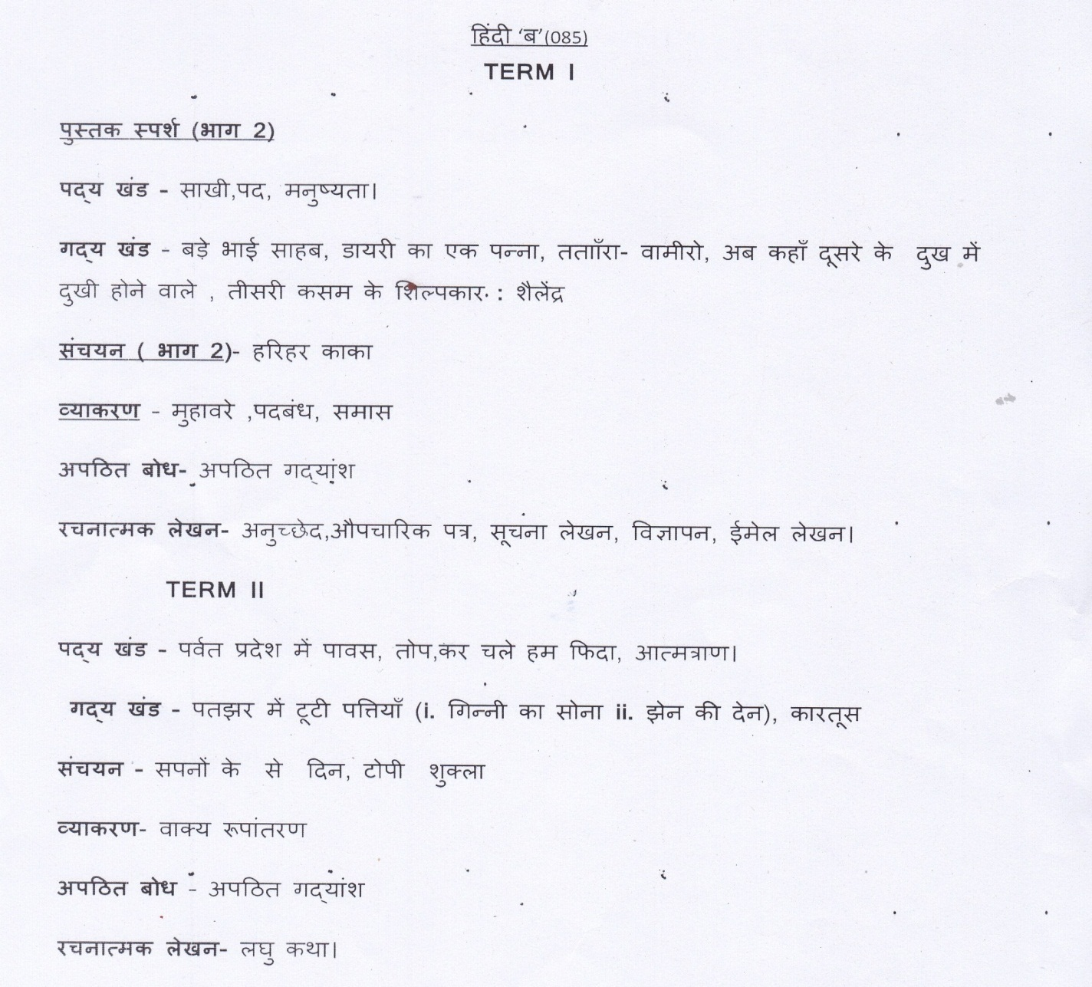

PUNJABI (004)
TERM I

ਸਾਹਿਤ ਮਾਲਾਃ
ਕਾਵਿ ਰਚਨਾਵਾਂ -ਸੋ ਕਿਉ ਮੰਦਾ ਆਖੀਐ, ਕਿਰਪਾ ਕਰ ਕੇ ਬਖਸਿ ਲੈਹੁ ,ਤੂੰ ਮੇਰਾ ਪਿਤਾ ਤੂੰ ਹੈ ਮੇਰਾ ਮਾਤਾ।
ਵਾਰਤਕ: ਪ੍ਰਾਰਥਨਾ, ਮੇਰੇ ਵੱਡੇ ਵੱਡੇਰੇ
,ਘਰ ਦਾ ਪਿਆਰ ,ਬੋਲੀ ।
ਵੰਨਗੀ :
ਕਹਾਣੀਃ ਕੁਲਫ਼ੀ, ਅੰਗ -ਸੰਗ, ਧਰਤੀ ਹੇਠਲਾ ਬਲ਼ਦ।
ਇਕਾਂਗੀ : ਜ਼ਫ਼ਰਨਾਮਾ

ਵਿਆਕਰਨ: ਸਮਾਸੀ ਸ਼ਬਦ, ਬਹੁਅਰਥਕ ਸ਼ਬਦ, ਕਿਰਿਆ ਵਿਸ਼ੇਸ਼ਣ, ਅਗੇਤਰ -ਪਿਛੇਤਰ, ਲੇਖ ਰਚਨਾ, ਪੱਤਰ (ਨਿੱਜੀ ਤੇ ਬਿਨੈ ) ਚਿੱਤਰ ਵਰਨਣ,ਅਣਡਿੱਠਾ ਪੈਰਾ, ਅਣਡਿੱਠੀ ਕਾਵਿ ਟੁਕੜੀ, ਮੁਹਾਵਰੇ ਕ ਤੋਂ ਚ ਤੱਕ ।

TERM II

ਜੰਗ ਦਾ ਹਾਲ, ਸਤਿਗੁਰ ਨਾਨਕ ਪ੍ਰਗਟਿਆ।
ਇਕਾਂਗੀ : ਦੂਜਾ ਵਿਆਹ।
ਵਾਰਤਕ : ਤੁਰਨ ਦਾ ਹੁਨਰ
ਵਿਆਕਰਨ : ਸਮਾਸੀ ਸ਼ਬਦ, ਬਹੁ ਅਰਥਕ ਸ਼ਬਦ,ਅਗੇਤਰ - ਪਿਛੇਤਰ, ਲੇਖ ਰਚਨਾ, ਪੱਤਰ (ਨਿੱਜੀ ਤੇ ਬਿਨੈ), ਚਿੱਤਰ ਵਰਨਣ, ਅਣਡਿੱਠਾ ਪੈਰਾ, ਅਣਡਿੱਠੀ ਕਾਵਿ ਟੁਕੜੀ, ਮੁਹਾਵਰੇ ਚ ਤੋਂ ਝ ।
ਸਾਰੇ ਸਿਲੇਬਸ ਦੀ ਦੁਹਰਾਈ.

MATHEMATICS (041)

TERM I
Chapter 1 Real Numbers
Chapter 2 Polynomials
Chapter 3 Pair of Linear Equations in Two Variables Chapter 6 Triangles
Chapter 7 Coordinate Geometry Chapter 8 Introduction to Trigonometry Chapter 11 Areas Related to Circles Chapter 14 Probability

TERM II
Chapter 4 Quadratic Equations
Chapter 5 Arithmetic Progressions
Chapter 9 Some Applications of Trigonometry Chapter 10 Circles
Chapter 12 Surface Areas and Volumes Chapter 13 Statistics

SCIENCE (086)
TERM I
Chapter- 1 Chemical Reactions and Equations Chapter- 2 Acids, Bases and Salts
Chapter- 3 Metals and Non- metals Chapter- 5 Life Processes
Chapter- 6 Control and Coordination
Chapter-9 Light – Reflection and Refraction
Chapter- 10 The Human Eye and the Colourful World

TERM II
Chapter- 4 Carbon and Its Compounds Chapter- 7 How Do Organisms Reproduce? Chapter- 8 Heredity
Chapter- 11 Electricity
Chapter- 12 Magnetic Effects of Electric Current Chapter- 13 Our Environment

SOCIAL SCIENCE (087)
TERM I
History:
Chapter- 1 The Rise of Nationalism in Europe
Chapter- 2 Nationalism in India
Geography:
Chapter- 1 Resources and Development
Chapter- 2 Forest and Wildlife Resources
Chapter- 3 Water Resources
Chapter-4 Agriculture
Political Science:
Chapter- 1 Power Sharing
Chapter- 2 Federalism
Chapter- 3 Gender, Religion and Caste
Economics:
Chapter- 1 Development
Chapter- 2 Sectors of the Indian Economy
TERM II
History:
Chapter- 3 The Making of a Global World (Subtopics 1 to 1.3)
Chapter- 4 The Age of Industrialization (To be assessed as part of Periodic Assessment only)
Chapter- 5 Print Culture and the Modern World
Geography:
Chapter- 5 Minerals and Energy Resources
Chapter- 6 Manufacturing Industries
Chapter- 7 Life Lines of National Economy (Only map pointing to be evaluated in the Board Examination)
Political Science:
Chapter- 4 Political Parties
Chapter- 5 Outcomes of Democracy Economics:
Chapter- 3 Money and Credit
Chapter- 4 Globalization and the Indian Economy
What is Globalisation?
Factors that have enabled Globalisation
Note :- Project on Disaster Management and Consumer Rights will be given during summer vacation .
Interdisciplinary project as part of multiple assessment
- The Making of a Global World
- Lifelines of National Economy
- Globalisation and the Indian Economy

INFORMATION TECHNOLOGY (402)

TERM I
PART-A Employability Skills Unit-1 Communication Skills-II Unit-2 Self Management-II
Unit-3 Information and Communication Skills-II

PART-B Subject Specific Skills
Unit-1 Digital Documentation (Advanced) using Libre Office writer
Unit-2 Electronic Spreadsheet (Advanced) using Libre Office Calc
Unit-3 Database Management System using Libre Office Base

TERM II
PART-A Employability Skills Unit-4 Entrepreneurial Skills-II Unit-5 Green Skills-II

PART-B Subject Specific Skills
Unit-3 Database Management System. using Libre Office Base
Unit-4 Maintain Healthy, Safe and Secure Working Environment.
PART-C Practical Work.
PART-D Project Work

ART & CRAFT

TERM I

- Abstract Art
- Salt Art
- Warli Art
- Madhubani Art

TERM II
- Positive & Negative Art
- Halloween Art
- Coffee Painting
- Micrography Portraits

